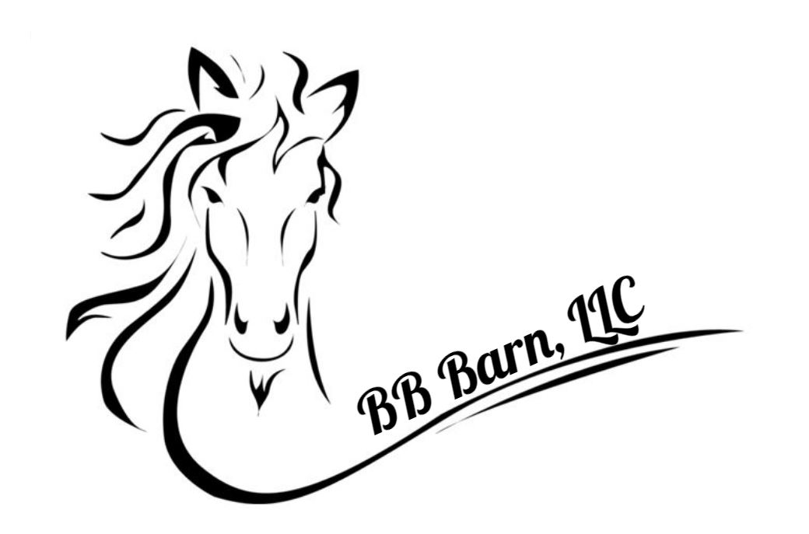
HORSE RIDING AGREEMENT AND LIABILITY RELEASE FORM

This form must be completed by and for each participant.
PREMISE OWNERS 'NAME IS Jim Berling and Michelle Berling, hereinafter known as BB Barn.
LOCATION OR ADDRESS: 4511 Waynes Trace Rd. Hamilton, Ohio 45011.

PLEASE READ CAREFULLY BEFORE SIGNING

SERIOUS INJURY MAY RESULT FROM YOUR PARTICIPATION IN THIS ACTIVITY. BB BARN DOES NOT GUARANTEE YOUR SAFETY OR THAT OF YOUR HORSE. IT IS HEREBY AGREED TO AS FOLLOWS THAT:

- REGISTRATION OF RIDERS AND AGREEMENT PURPOSE I, the following individual hereinafter known as the “RIDER”, and the parents or legal guardians thereof if a minor, do herby voluntarily request and agree to participate in horse riding on premises BB Barn, and that this RIDER will ride his/her own horse or one borrowed or leased by RIDER’S own arrangement today and on all future dates:

RIDER NAME: ___________________________________________________________

- AGREEMENT SCOPE AND TERRITORY AND DEFINITIONS – This agreement shall be legally binding upon me the registered RIDER, and the parents or legal guardians thereof if a minor, my heirs, estate, assigns, including all minor children, and personal representatives; and it shall be interpreted according to the laws of Butler County, Ohio. Any disputes by the RIDER shall be litigated in and the venue shall be Butler County, Ohio.

The term “HORSE” herein shall refer to all equine species. The term “HORSEBACK RIDING” or “RIDING” herein shall refer to riding or otherwise handling of horses, ponies, mules, or donkeys, whether from the ground or mounted. The term “RIDER” shall herein refer to a person who rides a horse mounted or otherwise handles or comes near a horse from the ground.
The terms “I”, “me”, “my” shall herein refer to the above registered rider and the parents or legal guardians thereof if a minor.

- ACTIVITY RISK CLASSIFICATION – Horseback riding is classified as RUGGED ADVENTURE RECREATIONAL SPORT ACTIVITY, and that there are numerous obvious and non-obvious inherent risks always present in such activity despite all safety precautions. According to NEISS (National Electronic Injury Surveillance Systems of the United States Consumer Products) horse activities rank 64th among the activities of people relative to injuries that result in a stay at U.S. hospitals. Related injuries can be severe, requiring more hospital days and resulting in more lasting residual effects than injuries in other activities.

- NATURE OF RIDING HORSES – No horse is a completely safe horse. Horses are 5 to 15 times larger, 20 to 40 times more powerful, and 3 to 4 times faster than a human. If a rider falls from a horse to ground it will generally be at a distance of from 3 ½ to 5 ½ feet, and the impact may result in injury to the rider. Horseback riding is the only sport where a much smaller, weaker predator animal (human) tries to impose its will on , and become one unit of movement with, another much larger, stronger prey animal with a mind of its own (horse) and each has a limited understanding of the other. If a horse is frightened or provoked it may divert from its training and act according to its natural survival instincts which may include, but are not limited to: stopping short, changing directions or speed at will; shifting its weight; bucking; rearing; kicking; biting; or running from danger.

- RIDER RESPONSIBILITY – Upon mounting a horse and taking up the reins, the RIDER is in primary control of the horse. The RIDER’S safety largely depends upon his/her ability to carry out simple instructions, and his/her ability to remain balanced aboard the moving animal. The RIDER shall be responsible for his/her own safety.

- CONDITIONS OF NATURE – BB Barn is NOT responsible for total or partial acts, occurrences, or elements of nature that can scare a horse, cause it to fall, or react in some other unsafe way. SOME EXAMPLES ARE: thunder, lightening, rain, wild and domestic animals, insects, reptiles, which may walk, run, fly near, bite and/or sting a horse or person; and irregular footing on out-of-door groomed or wild land which is subject to constant change in condition according to weather, temperature, and natural and man-made changes in landscape.

- INSPECTION OF PREMISES – RIDER has inspected BB Barn facilities and land and is satisfied that all premises conditions are reasonably safe for RIDER’S intended purpose, usage and presence upon the BB Barn premises.

- ACCIDENT/MEDICAL AND PERSONAL LIABILITY INSURANCE – Should medical treatment be required, I and/or my own accident/medical insurance company shall pay for such incurred expenses. Should my actions or that of my horse cause injury or damage of any kind, I and/or my own personal liability shall pay for such damages.

- PROTECTIVE HEADGEAR WARNING – I have been fully warned and advised by BB Barn that the RIDER should purchase and wear protective headgear (riding helmet) and that the wearing of such headgear while mounting, riding, dismounting, and otherwise being around horses, may prevent or reduce severity of some head injuries and even prevent death from happening as a result of a fall or other occurrence. Minors 16 and under are required to wear protective headgear.

- LIABILITY RELEASE – In consideration of BB Barn allowing my participation in this activity, under the terms set forth herein, I, the RIDER, and the parent or guardian thereof if a minor, do agree to hold harmless and release BB Barn, it’s owners, agents, employees, officers, members, premise owners, insurers, and affiliated organizations from legal liability due to BB Barn ordinary negligence; and I do further agree that except in the event of BB Barn gross negligence and willful and wanton misconduct. I shall not bring any claims, demand, legal actions and causes of action, against BB Barn and/or its associates, for any economic and non-economic losses due to bodily injury, death, property damage sustained by me and/or my minor child or legal ward in relation to the premises and operations of BB Barn, to include while riding, handling, or otherwise being near horses owned by or in the care, custody and control of BB Barn.

All Riders and Parents or Legal Guardians (if rider is a minor) must sign below after reading this entire document:

SIGNER STATEMENT OF AWARENESS

I/WE, THE UNDERSIGNED, HAVE READ AND DO UNDERSTAND THE FOREGOING AGREEMENT, WARNINGS, RELEASE AND ASSUMPTION OF RISK, I/WE FURTHER ATTEST THAT ALL FACTS RELATING TO THE APPLICANT ARE TRUE AND ACCURATE.

­­­­­­­­­­­___________________________________________________________ ___________
SIGNATURE OF RIDER (Parent/Guardian must sign for rider 17 & Under) DATE

___________________________________________________________
PRINTED NAME OF RIDER

______________________________________________________
PRINTED NAME OF PARENT/GUARDIAN (if applicable)

